SIMATS ENGINEERING

Department of Computer Science and Engineering

CSA10 – SOFTWARE ENGINEERING

ASSIGNMENT 1 – CO1

Design, Simulate and Validate an Agile Delivery Strategy

for the Omnichannel Order Fulfilment Platform

CO2: Anaiyze software requirements to design scalable and efficient system architectures using collaborative tools like jira and confluence along with structured modeling techniques such as UMLdiagrams and architectural design patterns
Student Name | Talla Jahnavi | Register Number | 1925260100
Department / Section | B.Tech CSE (AIML) | Academic Year / Semester | 2026-2027/2 nd
Faculty Name | S Nanthini | Nature of Assignment | Individual
Duration | 1 Week | Total Marks | 50
Date of Submission |  | Date of Evaluation

MARK SHEET (Rubric-based Evaluation)
Task | Task Title | Max | Marks Awarded | Remarks
1 | Problem Investigation and Delivery Outcomes | 5
2 | Agile and Lean Operating Model | 6
3 | Prioritized Product Backlog (Jira / Selected Tool) | 8
4 | Capacity-Based Release Plan and Workflow | 7
5 | Delivery Simulation and Design Validation | 7
6 | Scaled Delivery Redesign and Validation (Day-4) | 12
7 | Individual Technical Reflection | 5
 | TOTAL | 50

OVERALL REMARKS

Student Signature | Faculty Signature | Program Director
Talla Jahnavi

Task 1 – Investigate Stakeholder Needs and Resolve Conflicts
Q1 – Investigate Stakeholder Needs and Resolve Conflicts 5 Marks
Investigate the needs of customers, pickers, support agents, administrators, store managers and finance reviewers.
- Formulate at least three questions that investigate an unresolved requirement or stakeholder conflict.
- Gather findings through a small stakeholder discussion, questionnaire or process review. Where access is unavailable, use clearly labelled simulated responses.
- Identify at least three conflicting expectations.
- Develop and justify a resolution for each conflict.
- Define the system boundary, principal actors and scope exclusions.
Do not assume that every stakeholder request should become a requirement.
Evidence Expected
Investigation questions, findings or labelled simulated responses, a stakeholder analysis, conflict-resolution decisions and a justified system boundary.

1.1 Stakeholder investigation questions
A short process-review questionnaire is proposed for the six stakeholder groups. The following questions focus on unresolved rules rather than collecting general opinions.
Question | Stakeholders | Purpose
When two customers request the final unit at almost the same time, should checkout wait for a stock reservation result or accept both orders and resolve stock later? | Customer, picker, store manager | Clarifies the priority between checkout speed and stock accuracy.
Which order details should a support agent see, and which actions must remain restricted? | Customer, support agent, administrator | Defines privacy boundaries and role permissions.
Who may approve a refund above the standard limit, and what must happen if the gateway fails after approval? | Finance reviewer, support agent, customer | Separates refund request, approval and execution.
If an order is stored but the courier service is unavailable, what status should be shown and who is responsible for retrying? | Picker, support agent, store manager, administrator | Defines persistence, customer communication and integration recovery.

1.2 Simulated stakeholder findings
The findings below are simulated process-review responses, clearly labelled as such. They are suitable for initial design but must be confirmed with real stakeholders before implementation.
Stakeholder | Simulated need | Requirement/design implication
Customer | Fast checkout, accurate availability, clear tracking and privacy. | Show stock result and meaningful order milestones; do not expose internal or payment credentials.
Warehouse picker | Reliable pick list linked to a reserved quantity and paid order. | Only eligible assigned orders appear; picking is confirmed before dispatch.
Support agent | Ability to find an order and explain returns without seeing card information or unrelated customers’ data. | Provide scoped order lookup and masked contact information; deny cross-customer access.
Administrator | Manage roles, regional policies and operational corrections with accountability. | Use server-side permissions and audit policy changes and stock adjustments.
Store manager | Consolidated sales, stock and refund reporting. | Provide region-scoped reporting with a visible data-refresh time.
Finance reviewer | Evidence for refunds and control over approvals above the permitted limit. | Separate request, approval and execution; preserve the approval and failure history.

1.3 Conflicting expectations and resolutions
Conflict | Resolution | Reason and observable outcome
Checkout speed versus stock accuracy | Reserve stock atomically with order creation. Use the assignment’s illustrative 15-minute expiry as a planning assumption. | Correct stock is more important than accepting an order that cannot be fulfilled. When two buyers compete for the last unit, only one reservation succeeds.
Support visibility versus customer privacy | Support sees order status and masked contact details only; payment card data is not stored or exposed. | Support can answer normal questions while the API rejects access to another customer’s order.
Instant payment confirmation versus integration availability | Store the local order as Payment Pending and mark it Paid only after a verified gateway callback. | A browser redirect is not proof of payment. A repeated or delayed callback must not create a second payment.
Fast refunds versus finance control | Support may request a refund; an authorized finance reviewer approves refunds above the assumed limit; gateway execution is a separate step. | An agent or customer cannot approve their own refund. A failed execution remains Failed/Pending and is not displayed as refunded.

1.4 System boundary, actors and exclusions
The system boundary includes the storefront catalogue, cart and checkout, protected application interface, authentication and authorization, order management, stock reservation, payment callback handling, warehouse picking dashboard, tracking view, returns and refunds, reporting, relational persistence, audit records and integration worker. The platform owns the local order lifecycle, stock reservation records, payment-event identities, refund workflow state and durable integration requests.
Principal actors are Customer, Picker, Support Agent, Finance Reviewer, Store Manager and Administrator. The Payment Gateway and Courier API are external systems. Warehouse scanners and human reviewers provide input through controlled interfaces. The build and deployment service is outside the runtime business boundary.
First-release exclusions are autonomous refund decisions, machine-learning demand forecasting, public third-party API access, real card-data storage and unrestricted offline approval. Synthetic products, orders and stock events are used. Human responsibility remains mandatory for refund approval and stock corrections.

Task 2 – Create a Prioritized and Testable Requirements Specification
Q2 – Create a Prioritized and Testable Requirements Specification 8 Marks
Create a requirements specification in a selected collaborative documentation tool and represent prioritized requirements in a selected issue tracker. Jira and Confluence are reference options; justify the arrangement chosen.
- At least twelve functional requirements and six non-functional requirements.
- Unique identifiers, sources, priorities and acceptance criteria.
- Order rules covering price and tax calculation, stock reservation, ownership, permitted status changes, dispatch deadlines, duplicate payment callbacks and refund approvals.
- Measurable quality requirements for performance, availability, security and usability.
- Explicit assumptions and unresolved questions.
- A justified prioritization method.
- Replacement of vague statements such as “checkout should be fast” with requirements that specify the operating condition and an observable acceptance threshold.
- An explanation of how at least two stakeholder conflicts influenced the final specification.
Evidence Expected
Collaborative specification, requirement records, measurable acceptance criteria, prioritization rationale and documented assumptions.

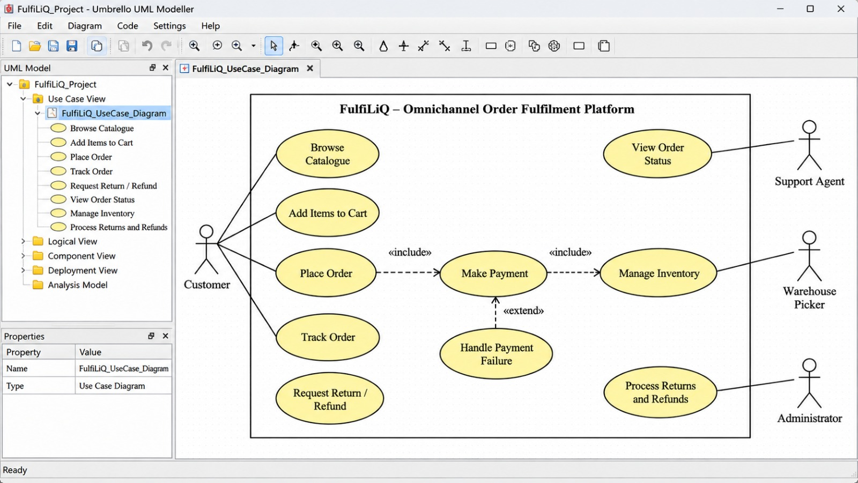
2.1 Collaborative tools and issue tracking
The selected arrangement is Confluence for the canonical requirements specification, decision records and review notes, with Jira for implementation issues. Each Jira issue contains the requirement ID, priority, owner, status and acceptance criteria, and links to the corresponding Confluence section, UML model and implementation change. Confluence pages link back to Jira. This supports collaborative editing, review history, ownership, traceability and sprint planning. Limitations include licensing cost, dependence on hosted services and possible duplication; use one canonical requirement statement, links rather than copied text, and periodic exports.
A second suitable arrangement is GitHub Issues and Projects with Markdown requirements and version-controlled UML source. It offers pull-request review, history and low initial cost, but may be less accessible to nontechnical stakeholders and less convenient for formal requirement reporting. Confluence plus Jira is selected for stakeholder accessibility and explicit requirement-to-work-item traceability. Umbrello is used for UML modelling; exported diagrams and model files are linked from the requirement records.
2.2 Prioritization method
MoSCoW is used with a customer-harm and control-risk override. Must requirements protect correct orders, stock, payment, privacy or refund authority. Should requirements materially improve operations but can follow without breaking core invariants. Could requirements are useful enhancements that may be deferred. The priorities are design recommendations for the representative release, not actual stakeholder votes.
2.3 Functional requirements
ID | Requirement | Source | Priority | Acceptance criterion
FR01 | Authenticate and authorize requests | All role groups; Administrator | Must | Every protected operation checks authenticated identity, role and scope on the server; unauthorized requests are rejected without changing data.
FR02 | Place an order | Customer | Must | Required fields and positive quantities are validated; order is created only after successful server-side validation and stock reservation.
FR03 | Reserve stock atomically | Customer; Picker; Store Manager | Must | For two competing requests for the last unit, one reservation succeeds and the other is rejected; available stock never becomes negative.
FR04 | Calculate price and tax | Customer; Store Manager; Administrator | Must | Server calculates item totals, discounts, shipping and regional tax from approved policy; client-supplied totals are ignored and test cases match the approved calculation table.
FR05 | Confirm payment idempotently | Customer; Payment Gateway; Finance Reviewer | Must | A verified gateway/event identity creates at most one payment and one confirmation; replay returns the stored result; invalid signature or amount is rejected.
FR06 | Enforce order lifecycle | Picker; Support Agent; Customer | Must | Only permitted transitions are accepted; dispatch requires confirmed payment and pick confirmation; stale versions are rejected.
FR07 | Generate pick list | Picker | Should | Picker sees only assigned orders that are paid and have reserved stock.
FR08 | Expire reservations | Customer; Store Manager; Picker | Must | An unpaid reservation is released after the assumed 15-minute period exactly once; a late payment callback follows a defined recovery path.
FR09 | Dispatch and track order | Picker; Customer; Support Agent | Should | Dispatch stores a courier reference and timestamp; customer/support views show permitted milestones only.
FR10 | Request, approve and execute refund | Support Agent; Finance Reviewer; Customer | Must | Refund request, approval/rejection and gateway execution are separate states; execution is blocked unless required approval exists.
FR11 | Synchronize gateway and courier status | Administrator; Operations | Must | A durable integration intent is stored with the local transaction; retries use a stable correlation identity and do not create a second logical shipment/payment.
FR12 | Audit and report | Administrator; Finance Reviewer; Store Manager | Should | Privileged transitions record actor, UTC time, entity, action and version; authorized report totals reconcile with source records.

2.4 Non-functional requirements
ID | Quality attribute | Source | Priority | Measurable acceptance criterion
NFR01 | Performance | Customer; Store Manager | Must | Proposed checkout API p95 is below 800 ms for 50 concurrent synthetic users in a 15-minute test after warm-up; report host, dataset, errors and p50/p95/p99.
NFR02 | Consistency | Picker; Finance Reviewer | Must | Concurrent last-unit and duplicate-callback tests produce no negative stock, duplicate payment or duplicate confirmation.
NFR03 | Recoverability | Administrator; Operations | Should | After a controlled worker restart, pending integration intents resume within the proposed 15-minute recovery target; committed local records are not lost, subject to database backup configuration.
NFR04 | Security and privacy | Customer; Support Agent; Finance Reviewer | Must | Positive and negative endpoint tests cover all six role categories; support cannot read another customer’s order or payment credentials; no card number or CVV is stored.
NFR05 | Usability and accessibility | Customer; Picker | Should | Checkout, picking and tracking can be operated by keyboard; status is conveyed in text and not by colour alone; validation errors state how to correct the issue.
NFR06 | Portability and reproducibility | Engineering; Administrator | Could | A tagged release and documented configuration can be deployed on a clean supported host with repeatable steps.

2.5 Business rules and assumptions
- Price and tax: the server calculates subtotal, discount, shipping and tax using the customer’s region and a recorded policy version. The accepted total is stored with the order. Monetary values use the currency’s minor unit and approved rounding rules.
- Stock: available quantity equals on-hand quantity minus reserved quantity. Reservation is committed atomically with order creation. The invariant is 0 ≤ reserved ≤ on-hand.
- Ownership: each order has one customer owner. Customers can read only their own orders. Support access is role- and scope-checked and audited. A role selected in the interface cannot grant authority.
- Order status: Placed → Paid → Packed → Dispatched → Delivered → Closed. Cancellation is permitted before payment under the initial policy. A return is a separate authorized workflow after delivery.
- Dispatch deadline: the proposed target is dispatch within 24 hours after verified payment, measured in UTC. Breaches are recorded for operations review.
- Duplicate callbacks: gateway identity and event identity are unique together. The callback signature and amount are verified before the order becomes Paid. A replay returns the previous result.
- Refunds: refunds above the assumed threshold require finance approval. Request, approval/rejection and execution are distinct states. A failed execution is not displayed as a completed refund.
Planning assumptions: 50 concurrent synthetic users, 100 stock/payment/scan events per minute, 15-minute reservation expiry, 24-hour dispatch target, UTC timestamps and a provisional INR 5,000 refund approval threshold. These are assumptions for design and testing, not confirmed retailer policy.
Unresolved questions include the approved refund threshold, reservation expiry, late-payment compensation, regional return windows, tax rounding, address and audit retention periods, payment gateway reconciliation contract, courier idempotency support and required service availability. The conflict between checkout speed and stock accuracy led to FR03/FR08; the conflict between rapid refunds and financial control led to FR10; privacy concerns led to FR01/NFR04.

Task 3 – Construct UML Models and Maintain Traceability
Q3 – Construct UML Models and Maintain Traceability 7 Marks
Create a consistent set of UML models covering:
- A use case diagram showing actors and principal interactions.
- A class diagram representing important domain concepts and relationships.
- A sequence diagram tracing a payment callback through order confirmation, shipment creation and courier synchronization, including a retry or failure.
- A state machine for Placed, Paid, Packed, Dispatched, Delivered and Closed orders, including authorized cancellation or return if supported.
- Approval, rejection, execution and rollback behaviour for refunds, modelled where relevant.
- A traceability matrix connecting Requirement → UML Element → Architectural Component → Validation Scenario.
- Identification and resolution of at least two inconsistencies discovered while connecting these representations.
Evidence Expected
Four UML diagrams, a traceability matrix, identified inconsistencies and documented corrections.

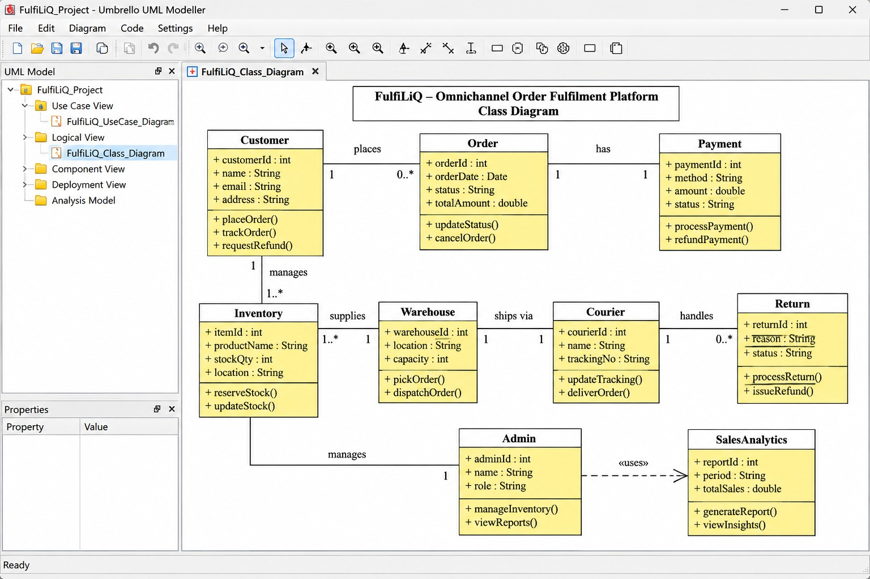
3.1 Use-case diagram – Umbrello example
In Umbrello, create a Use Case Diagram, draw the system boundary named “Omnichannel Order Fulfilment Platform”, place the actors outside it and the use cases inside it. Connect actors with associations. Add an «include» relationship from each protected use case to Authenticate and Authorize. Keep refund approval separate from refund execution.
CUSTOMER PICKER
| |
(Place Order) (View Pick List)
(View Own Order) (Confirm Pick)
(View Tracking) (Dispatch Order)
\ /
\ /
+------------------------------------------------+
| OMNICHANNEL ORDER FULFILMENT PLATFORM |
| (Authenticate and Authorize) |
| (Reserve Stock) (Calculate Price and Tax) |
| (Confirm Payment) (Manage Order Status) |
| (Request Return/Refund) |
| (Approve / Reject Refund) |
| (Execute Approved Refund) |
| (View Reports) (Manage Roles and Policies) |
+------------------------------------------------+
/ | | |
SUPPORT AGENT FINANCE REVIEWER MANAGER ADMINISTRATOR
^ ^
| |
(Search Scoped Order) (View Reports)

PAYMENT GATEWAY --> (Send Signed Callback)
COURIER API <-- (Create Shipment / Tracking Update)
Umbrello construction note: use Actor, Use Case, System Boundary and Association tools. For «include», draw a dashed dependency arrow from the protected use case to Authenticate and Authorize and label it «include». External gateway and courier actors remain outside the boundary.
3.2 Class diagram – Umbrello example
The domain model below identifies core entities and multiplicities. In Umbrello, create a Class Diagram, add each class with its attributes, and connect classes with associations. Add multiplicities at both ends. Add a constraint note to StockItem and a uniqueness note to PaymentEvent.
+------------------+ 1 owns 0..* +----------------------+
| User |------------------------>| Order |
|------------------| |----------------------|
| userId | | orderId |
| role | | ownerId |
| regionId | | state |
| active | | total |
+------------------+ | version |
+----------+-----------+
| 1
contains 1..* |
+----------v-----------+
| OrderLine |
|----------------------|
| sku, quantity |
| unitPrice |
+----------------------+

+------------------+ 1 0..* +----------------------+
| StockItem |--------------| Reservation |
| sku | | reservationId |
| onHand | | quantity |
| reserved | | expiresAt |
| version | | state |
+------------------+ +----------+-----------+
| 0..*
| belongs to 1
+------v---------------+
| Order |
+-----------------------+

Order 1 -------- 0..* PaymentEvent
Order 1 -------- 0..* RefundRequest
Order 1 -------- 0..* AuditEvent
Order 1 -------- 0..* IntegrationIntent
PaymentEvent: unique(gatewayId, eventId)
StockItem constraint: 0 <= reserved <= onHand
RefundRequest: Requested / Approved / Rejected / Executed / Failed
Class | Important attributes | Relationship / rule
User | userId, role, regionId, active | One user may own many orders; role and region scope govern operations.
Order | orderId, ownerId, state, total, regionId, policyVersion, version | Has order lines, reservations, payment events, refund requests, audit events and integration intents.
OrderLine | lineId, sku, quantity, unitPrice | Belongs to one order; price is server-calculated and snapshotted.
StockItem | sku, onHand, reserved, version | Available = onHand − reserved; reserved cannot exceed onHand.
Reservation | reservationId, orderId, sku, quantity, expiresAt, state | Links an order line to stock and can be released only once.
PaymentEvent | gatewayId, eventId, orderId, amount, verificationState | Unique gateway/event pair prevents duplicate payment effect.
RefundRequest | refundId, orderId, amount, state, requestedBy, approvedBy | Execution requires valid approval; failure remains visible.
IntegrationIntent | intentId, orderId, purpose, correlationKey, status, attempts, externalId | Durable request for gateway/courier synchronization.
AuditEvent | eventId, actorId, entityType, entityId, action, occurredAt, version | Records privileged transitions.
RegionalPolicy | regionId, version, taxRules, shippingRules, refundLimit | Versioned rules referenced by each order.

3.3 Sequence diagram – payment callback and courier retry
Create a Sequence Diagram in Umbrello. Add lifelines for Customer, Payment Gateway, Order API, Database, Outbox Worker and Courier API. Add synchronous messages for verification and database work, a return message for acknowledgement, and an alternative fragment for timeout and retry.
Customer Gateway Order API Database Worker Courier
| | | | | |
| Pay | | | | |
|------------>| | | | |
| | Signed event | | | |
| |------------->| Verify event | | |
| | |-------------->| | |
| | | Record event, mark Paid, | |
| | | audit + intent | |
| | |-------------->| COMMIT | |
| |<-------------| Accepted / prior result | |
| | | | | |
| | | |<-----------| Claim intent|
| | | | |----------->|
| | | | | Timeout |
| | | |<-----------| Pending |
| | | | | Reconcile |
| | | | |----------->|
| | | | | Shipment ID|
| | | |<-----------| |
The database transaction stores the payment event, Paid transition, audit record and shipment intent together. A duplicate callback is recognized by its unique gateway/event identity and returns the existing result. If the courier times out, the worker retains a Pending intent and checks the correlation key before retrying. It does not blindly create another shipment.
3.4 State machine – order and refund
In Umbrello, create a State Diagram for Order. Use states and guarded transition labels. Create a second state diagram or a separate region for RefundRequest so that approval and execution are not confused with the order lifecycle.
[Initial] --> Placed
Placed -- verified payment --> Paid
Placed -- authorized cancellation / expiry --> Cancelled
Paid -- all reserved lines picked --> Packed
Packed -- payment + pick + dispatch guards --> Dispatched
Dispatched -- courier delivery confirmation --> Delivered
Delivered -- close after applicable return period --> Closed

Forbidden transitions:
Placed --> Dispatched
Paid --> Closed without delivery
Cancelled --> Paid without late-payment recovery

Refund workflow:
[Initial] --> Requested
Requested -- finance approval --> Approved
Requested -- authorized rejection --> Rejected
Approved -- gateway succeeds --> Executed
Approved -- gateway fails --> Failed
Failed -- controlled retry --> Executed or Failed

No transition from Requested or Rejected to Executed.
A return is permitted only under the configured return policy after delivery. Refund execution is not implied by return initiation or approval. A Failed refund retains its approval history and may be retried using the same refund identity.
3.5 Traceability matrix
Requirement | UML element | Architecture component | Validation scenario
FR01 | Use case Authenticate/Authorize; User class | Identity middleware and authorization policy | T6: unauthorized approval and cross-customer access denied.
FR03 | StockItem and Reservation classes | Stock reservation module and relational transaction | T1: two buyers compete for last unit.
FR05 | PaymentEvent class; callback sequence | Payment callback handler and unique event constraint | T2: repeated callback.
FR06 | Order state machine | Order command service | T4: dispatch without payment/pick confirmation.
FR08 | Reservation class and expiry transition | Stock module and expiry scheduler | T7: late payment after expiry.
FR10 | RefundRequest class and refund state machine | Refund workflow and finance authorization | T3/T6: failed execution and unauthorized approval.
FR11 | Sequence diagram and IntegrationIntent | Outbox integration worker | T5: courier timeout and retry.
NFR04 | Actor permissions in use-case model | Server-side identity and scoped data access | T6: support cannot access another customer’s order.

3.6 Inconsistencies found and corrections
Inconsistency | Why it is a problem | Correction
Browser payment-success page treated as proof of payment | A browser redirect can occur without a verified payment event. | Only a verified, amount-matched gateway callback changes the order to Paid.
Role selector in interface appeared to grant finance privileges | A user can manipulate interface state; it cannot establish authority. | Role is taken from authenticated server identity and checked at every protected endpoint.
Reservation expiry could release stock before a delayed payment callback | A late callback could mark an order Paid even after the unit had been resold. | Re-reserve if stock remains; otherwise record Payment Received / Needs Refund and block picking/dispatch.

Task 4 – Design and Justify Alternative Architectures
Q4 – Design and Justify Alternative Architectures 8 Marks
Develop two meaningfully different architectural alternatives for the system. Select appropriate patterns, such as a modular monolith, microservices or event-driven architecture. For each alternative:
- Define the principal components and responsibilities.
- Explain communication and data ownership.
- Describe how duplicate payment processing and overselling of the last unit would be prevented.
- Examine scalability, consistency, availability, security and operational complexity.
- Identify likely failure points and maintenance implications.
Then select an architecture and create component and deployment diagrams. Document at least three architectural decisions in your selected documentation tool. State each problem, alternatives, selection, justification and consequences.
Evidence Expected
Two architectural alternatives, a reasoned comparison, selected component and deployment diagrams, and three architectural decision records.

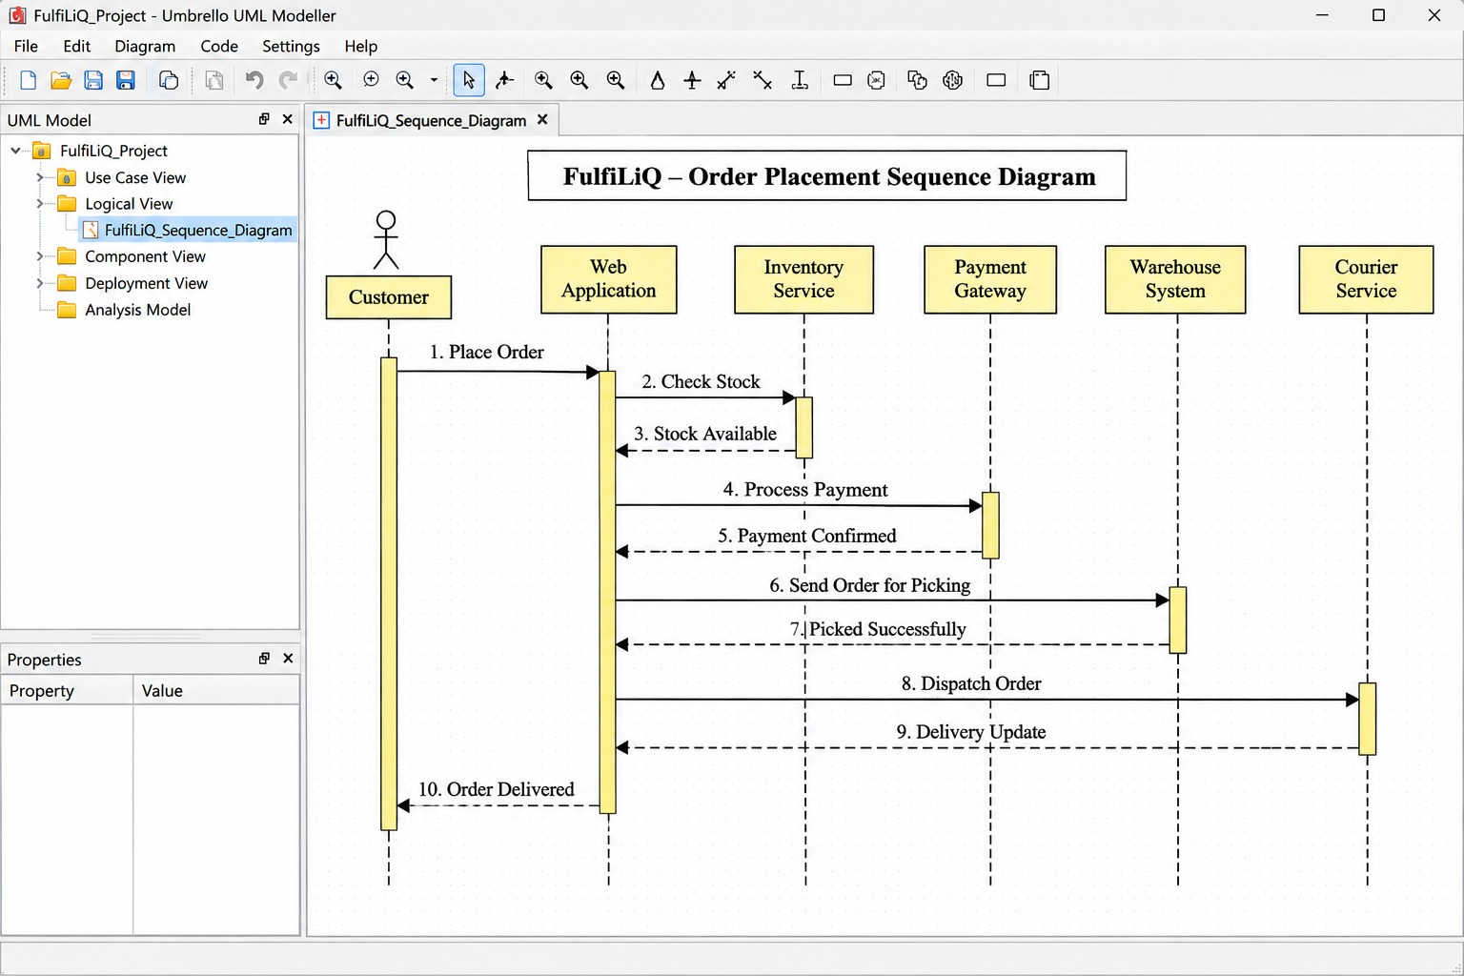
4.1 Alternative A: modular monolith with integration worker
The first alternative uses a React storefront and picker dashboard calling a protected REST API. One deployable application contains bounded modules for identity, catalogue and pricing, order, stock reservation, payment events, refunds, audit and reporting. PostgreSQL stores the local order, stock, payment-event identity, refund records and transactional outbox. A separately runnable worker sends gateway and courier requests. Jenkins builds and deploys versioned container images.
User commands use synchronous API calls and local database transactions. Partner synchronization is asynchronous. Order, stock, audit and integration intent can be committed in one database transaction. A unique constraint on gateway/event identity prevents duplicate payment effects. A conditional stock update or row lock ensures that two requests cannot reserve the same final unit.
4.2 Alternative B: microservices with event broker
The second alternative separates Identity, Catalogue/Pricing, Order, Inventory, Payment, Fulfilment/Tracking, Refund and Reporting into independently deployed services. Each service owns its data. Services communicate through versioned events on a durable message broker and synchronous APIs where immediate responses are needed. Cross-service workflows use sagas, idempotent consumers, outbox/inbox records and compensating actions.
Payment service deduplicates gateway event identities. Inventory serializes reservations per SKU or uses atomic conditional writes. Refund service independently enforces finance approval. The approach can scale hot services separately, but introduces eventual consistency, distributed tracing, schema governance, broker operations, deployment coordination and more complex recovery.
4.3 Architecture comparison
Dimension | Modular monolith + worker | Microservices + event broker
Consistency | Strong local transaction for order, stock, audit and intent. | Consistency within each service; cross-service workflows are eventually consistent and require compensation.
Duplicate payment | Unique gateway/event key in the relational database. | Payment inbox/unique key plus idempotent event consumers.
Last-unit stock | Conditional update or row lock in a local transaction. | Inventory service serializes per-SKU reservation or uses atomic conditional writes.
Scalability | Replicate stateless API and workers; database is main scaling boundary. | Scale inventory, payment and tracking independently.
Availability | Fewer components, but central database is a dependency. | Some failures can be isolated, but broker and service dependencies add failure modes.
Security | One API boundary with module-level permissions and scoped queries. | Fine-grained service identity is possible; service-to-service authorization is more complex.
Operations and cost | Lower initial infrastructure and monitoring burden. | More deployment units, monitoring, on-call work and specialist skills.
Maintenance | Shared schema needs discipline; easier end-to-end debugging. | Independent releases, but API/event compatibility and distributed debugging are harder.

4.4 Selected architecture and justification
Alternative A is selected for the representative release. The scenario states that the initial technical team is small and the deployment is modest. Order, stock, audit and integration intent need coordinated local transactions, which are simpler in one relational transaction. A worker isolates unreliable courier and gateway calls without requiring every module to become a separate service. The design can later extract a module only when measured workload, team ownership or availability requirements justify the extra cost.
4.5 Selected component diagram – Umbrello example
Create a Component Diagram in Umbrello. Use components for the interface, API, domain modules, database and integration worker. Connect components with dependencies and label external interfaces.
+------------------------+ HTTPS +--------------------------+
| Storefront / Picker UI |------------------>| Reverse Proxy / REST API |
+------------------------+ | Authentication + RBAC |
+------------+-------------+
|
+---------------------------------------+-------------------+
| Modular Application |
| +-----------+ +-----------+ +-----------+ +------------+ |
| | Order | | Stock / | | Payment | | Refund | |
| | Module | | Reserve | | Callback | | Workflow | |
| +-----------+ +-----------+ +-----------+ +------------+ |
| +-----------+ +-----------+ +-------------------------+ |
| | Pricing / | | Audit | | Reporting | |
| | Regional | | | | | |
| +-----------+ +-----------+ +-------------------------+ |
+---------------------------+------------------------------+
|
SQL / ACID
|
+---------v----------+
| PostgreSQL |
| Orders, Stock, |
| Events, Refunds, |
| Audit, Outbox |
+---------+----------+
|
Claim / retry
|
+---------v----------+
| Integration Worker|
+-----+----------+---+
| |
Payment API Courier API
4.6 Deployment diagram – Umbrello example
Create a Deployment Diagram. Represent the browser, reverse proxy, application container, database node, worker node and external partner systems as nodes. Show communication paths and trust boundaries.
+----------------------+ +----------------------+
| Customer Browser | | Picker Workstation |
+----------+-----------+ +----------+-----------+
| HTTPS | HTTPS
+-------------+-------------+
|
+-------v--------+
| Reverse Proxy |
+-------+--------+
|
+-------v--------+
| API Container | (stateless replicas)
| Web Interface |
+-------+--------+
| private network
+-------v--------+
| PostgreSQL |
| Persistent DB |
| Backup/Restore |
+-------+--------+
| private network
+-------v--------+
| Worker Node |
| Outbox Retry |
+----+-------+---+
| |
TLS | | TLS
+-----v--+ +--v-------+
|Gateway | |Courier |
| | |API |
+--------+ +----------+

Jenkins -> build/test -> versioned image -> controlled deployment
Trust boundaries: browser/API, application/database, partner APIs.
4.7 Architectural decision records
ADR | Problem and alternatives | Decision and justification | Consequences
ADR-01: Relational persistence | Need coordinated order, stock, approval, audit and intent updates. Alternatives include relational database or separate stores. | Choose PostgreSQL for relational constraints, transactions, unique keys and operational fit. | Requires schema migration discipline, backups and connection-pool management; database is a central dependency.
ADR-02: Integration delivery | Courier/gateway may be unavailable after local order commit. Alternatives include synchronous calls, best-effort calls or durable outbox. | Choose transactional outbox so local order and integration intent commit together and a worker retries later. | Requires worker monitoring, retry/backoff, reconciliation and pending statuses.
ADR-03: Authorization and idempotency | Browser state and repeated callbacks are untrusted. Alternatives include UI-only hiding or server-side checks. | Choose server-side identity/role/scope checks, unique callback identity, stable shipment/refund keys and version checks. | Requires negative authorization tests and conflict handling; prevents UI manipulation from granting authority.

Task 5 – Validate Critical Behaviour and Revise the Design
Q5 – Validate Critical Behaviour and Revise the Design 7 Marks
Define order and refund rules that must remain true throughout operation. Include invariants such as:
The same gateway event identity must not create multiple payments or order confirmations; an unapproved refund must not be marked as executed through an approval-gated operation.
Specify preconditions and postconditions for at least two critical operations. Construct at least six validation scenarios, including:
- Two customers attempting to buy the last unit of a product.
- A repeated payment callback arriving while the original callback is being processed.
- An approved refund failing at the gateway and requiring a controlled retry or rollback.
- A dispatch attempt without confirmed payment or pick confirmation.
- A courier synchronization request failing and then being retried.
- A customer or support agent attempting to approve a refund or access another customer’s order.
Before validation, predict the expected behaviour and identify which requirement or design decision should enforce it.
Validate using a small prototype, executable model, structured walkthrough or another justified method. Clearly distinguish demonstrated results from predictions.
Identify a weakness and revise the relevant requirements, UML models or architecture.
Evidence Expected
Invariants, operation contracts, six validation scenarios, expected and observed behaviour, validation evidence and a documented design revision.

5.1 Invariants
- Payment uniqueness: one gateway/event identity creates at most one accepted payment effect and one order confirmation.
- Refund authorization: a refund can be marked Executed only after a valid authorized approval exists.
- Stock safety: for each product, 0 ≤ reserved quantity ≤ on-hand quantity; available stock is never negative.
- Order ownership: each order has one owner; a customer reads only their own order and support access is restricted by role and scope.
- State integrity: every accepted transition satisfies the state guard, actor permission and expected entity version.
- Durability: a committed order has its integration intent persisted in the same transaction and eligible for retry.
5.2 Preconditions and postconditions
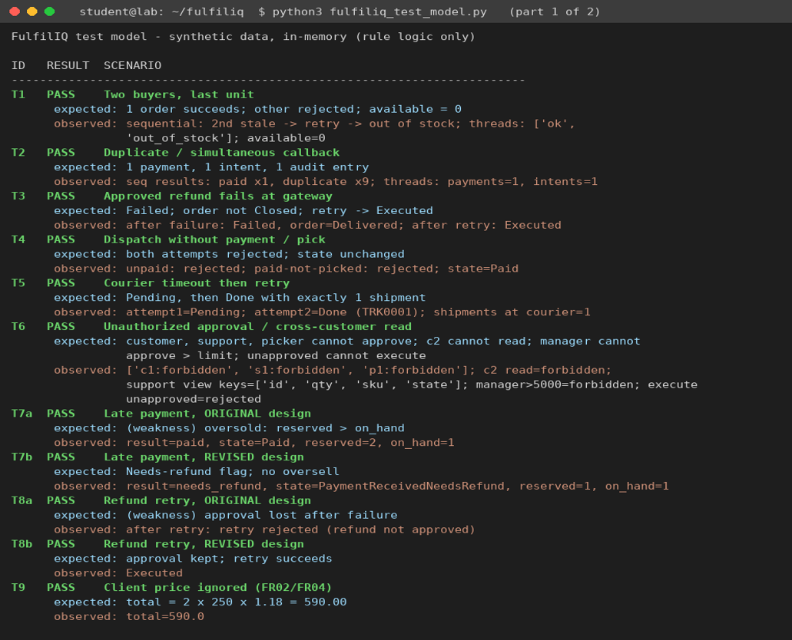  Operation | Preconditions | Postconditions
Place order | Authenticated active customer; positive quantities; valid SKU and price policy; stock available; expected stock version. | Success creates one Placed order, server-calculated total, reservation, audit event and required integration intent atomically. Failure creates no partial reservation or order.
Confirm payment | Valid gateway signature; matching order and amount; unseen gateway/event identity; order eligible or late-payment recovery applies. | Success records one payment event, marks Paid, appends audit and creates one shipment intent. Replay returns the existing result. Invalid callback changes nothing.

5.3 Validation scenarios – prediction and evidence
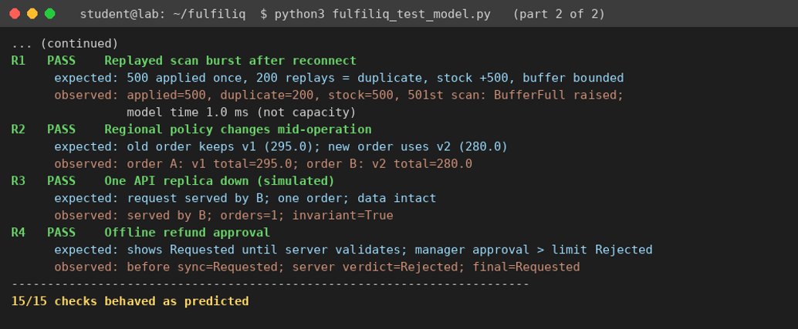
The assignment permits a small prototype, executable model or structured walkthrough. The earlier model-based validation used synthetic in-memory records and a lock-protected stock operation. It demonstrates rule logic only; it does not prove production database concurrency, real gateway security, deployed endpoint authorization or throughput.
Scenario | Predicted behaviour and enforcing design | Observed result / evidence boundary
T1. Two buyers attempt to buy the last unit | Exactly one reservation succeeds; the second is rejected; stock remains non-negative. FR03 and conditional stock update enforce it. | Model check passed: one success and one rejection. A simultaneous multi-session database test is still required.
T2. Same callback arrives repeatedly while processing | One payment event, one confirmation and one shipment intent. FR05 and unique gateway/event identity enforce it. | Model check passed: ten repeated deliveries resulted in one payment event. Real concurrent callback test remains required.
T3. Approved refund fails at gateway | Refund remains Failed; order is not shown as refunded; retry uses same refund identity and retained approval. FR10 enforces it. | Model check passed: failed attempt followed by successful controlled retry. Gateway adapter test remains required.
T4. Dispatch without payment or pick confirmation | Reject command without changing order state. FR06 and state guards enforce it. | Model check passed: dispatch was rejected until payment and pick were confirmed.
T5. Courier synchronization times out and retries | Intent remains Pending; worker reconciles by correlation key and does not create another logical shipment. FR11 enforces it. | Model check passed: retry reused the same logical shipment identity. Real courier contract test remains required.
T6. Customer/support agent attempts refund approval or cross-customer read | Reject at API boundary and record denial. FR01, FR10 and NFR04 enforce it. | Model check passed: unauthorized approval and cross-customer read were denied. Deployed endpoint and identity tests remain required.
T7. Payment arrives after reservation expiry | Re-reserve if stock remains; otherwise mark Payment Received / Needs Refund, block dispatch and initiate approval-gated refund. FR08 enforces it. | Model check passed: when stock had been resold, the order entered Needs Refund and stock remained non-negative.

5.4 Design weakness and revision
The first lifecycle allowed a delayed payment callback to mark an order Paid after its reservation had expired and the unit could have been resold. This could create a paid order that the warehouse could not fulfil. FR08 and the order state model were revised. A late callback now attempts an atomic re-reservation. If stock remains, the order can continue; if not, the system records Payment Received / Needs Refund, blocks picking and dispatch, and enters the approval-gated refund process. A second weakness was that a Failed refund could not be retried. The refund workflow was revised so failure retains the original approval and a controlled retry uses the same refund identity.
Evidence summary: the seven in-memory model checks passed on synthetic data. These are model results, not production results. Database concurrency, gateway callback verification, courier idempotency, real endpoint permissions, performance and recovery still require integration or deployment testing.

Task 6 – Redesign for Expansion and Partial Failure

Q6 – Redesign for Expansion and Partial Failure 10 Marks

Changed Requirement

The organization expands from three to twelve regions. The planning workload increases from 50 to 500 simultaneous users and from 100 to 1,000 stock, payment and scan events per minute. These are design assumptions rather than demonstrated system capacity.

Each region can define local tax, shipping and refund-approval rules.

A disconnected warehouse scanner node must buffer uniquely identified scan and stock events for later synchronization.

A locally queued refund approval must not be displayed as globally approved before server validation.

Management requires consolidated sales, stock and refund reports.

The operating budget permits only a limited increase in infrastructure expenditure.

Create a revised requirements and architecture design that addresses the expansion.
Component | Required Work | Marks
A. Diagnose the impact | Identify affected requirements, assumptions, components and quality attributes. | 2
B. Create the revised architecture | Redesign component responsibilities, data ownership, communication and deployment. Explain pending buffered events, deduplication and server-validated approval. | 4
C. Validate the redesign | Construct at least three additional scenarios covering increased load, synchronization and partial failure. Provide validation evidence appropriate to your method. | 2
D. Defend the design | Explain benefits, costs, consistency and availability trade-offs, and remaining limitations. | 2

Do not assume that increasing the number of services automatically improves scalability. Connect each architectural change to an identified requirement or limitation.

Evidence Expected

Impact analysis, revised requirements and diagrams, synchronization rules, validation findings and an evidence-supported architectural defence.

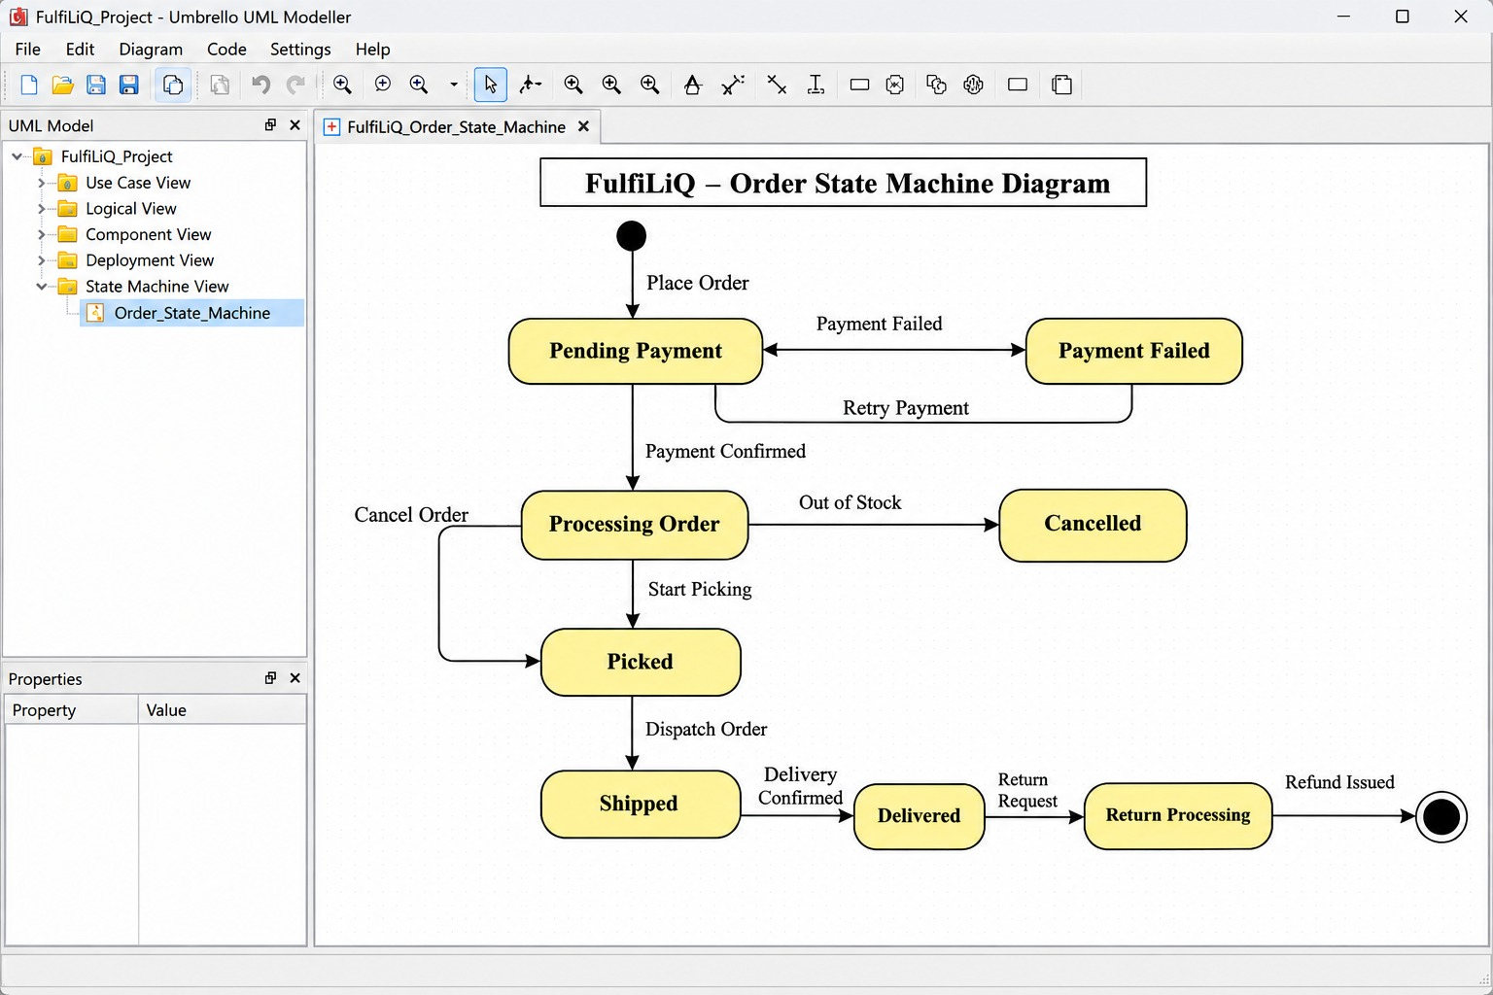
6.1 Impact diagnosis
The changed scenario expands from three to twelve regions, 50 to 500 simultaneous users and 100 to 1,000 stock, payment and scan events per minute. The average event rate is about 16.7 per second. A five-times burst assumption gives about 83 events per second. These are planning calculations, not measured capacity.
Affected requirement/component | Impact | Redesign response
FR04 pricing/tax; FR10 refund rules | Twelve regions may use different tax, shipping and refund policies. | Create versioned RegionalPolicy records; snapshot region and policy version on each order.
FR03/FR08 stock and reservation | More concurrency and offline scanners can submit stale stock observations. | Retain atomic central reservation, unique scanner event identities and stale-event reconciliation.
FR11 gateway/courier integration | Higher event volume and disconnected scanners create bursts and delayed delivery. | Use durable outbox/inbox, bounded queues, deduplication, backoff and dead-letter review.
FR01/NFR04 identity and scope | More regions increase cross-region exposure risk. | Enforce region and role scope on every server-side query and command.
NFR01 performance | 500 users and 1,000 events/minute may increase database contention. | Profile queries, add justified indexes, paginate lists, bound connection pools and batch event ingestion.
NFR03 recovery/reporting | Offline periods and consolidated reports increase recovery and query load. | Persist scanner events locally and build separate reporting summaries with visible refresh time.

6.2 Revised requirements
ID | Revised requirement | Acceptance criterion
FR13 | Versioned regional policy | Each order stores region and policy version used for tax, shipping and refund threshold; later policy changes do not silently rewrite existing orders.
FR14 | Offline scanner event buffer | Scanner persists each event with unique event ID, node ID, observed time and schema version in a bounded durable local queue; restart does not lose unacknowledged events.
FR15 | Deduplicate and reconcile scanner events | Server records each node/event identity once; replay causes no second stock mutation; stale observations are flagged and reconciled.
FR16 | Server-validated refund approval | Locally queued approval is displayed as Pending Validation; only authenticated server validation can set Approved after checking role, amount, region, policy version and refund state.
FR17 | Consolidated reporting read model | Regional transactions feed summary tables or a reporting view; report freshness timestamp and region coverage are visible.
NFR07 | Expanded workload target | Test 500 concurrent synthetic users and 1,000 events/minute, including stated burst profile; proposed checkout p95 remains below 800 ms with no invariant violations.
NFR08 | Offline queue recovery | Scanner queue has configured capacity, durable restart recovery, oldest-event-age display and a full-queue alert; overflow never silently discards events.

6.3 Revised responsibilities, data ownership and synchronization
The modular application remains the authority for global order, stock and refund state. The Regional Policy module owns versioned tax, shipping and refund rules. Each order snapshots region_id and policy_version. Scanners own only their local event journal while disconnected; they do not own global stock truth. A Scanner Synchronization interface authenticates each node, validates event schema, deduplicates event identity and reconciles stock changes using versions.
Each offline event stores node identity, unique event identity, SKU, quantity or movement, observed UTC time, schema version and local sequence. The scanner retains events until the server acknowledges durable acceptance. On reconnect, events are sent in bounded batches and retried with backoff. The server enforces uniqueness on node/event identity. Out-of-order or stale observations are quarantined or reconciled against the authoritative stock ledger rather than blindly applied as current stock.
A refund approval queued offline is only a request awaiting validation. The client displays Pending Validation. The central server checks authenticated identity, region, amount threshold, current policy version, refund state and reviewer authority before committing Approved. Until that server response is received, the approval must not be represented as globally approved.
For increased load, replicate stateless API containers behind a reverse proxy, use bounded worker concurrency, add indexes based on query plans, apply pagination, limit database connection pools and batch scanner events. Build reporting summaries separately from checkout transactions and display their refresh time. Do not create one microservice per module without evidence that independent scaling is needed.
6.4 Revised component diagram – Umbrello example
+---------------------------------------------------------------+
| Regional Storefronts / Picker Apps / Scanner Nodes (12) |
| Scanner Nodes: bounded durable offline event queue |
+----------------------------+----------------------------------+
| HTTPS / authenticated sync
v
+---------------------------------------------------------------+
| Regional-aware API |
| Identity + RBAC | Regional Policy | Scanner Synchronization |
+----------------------------+----------------------------------+
|
+----------------------------v----------------------------------+
| Modular Domain Application |
| Order | Stock/Reservation | Payment | Refund | Audit |
+----------------------------+----------------------------------+
| ACID transaction
v
+---------------------------------------------------------------+
| Primary PostgreSQL |
| Orders, Stock, Policy Versions, Callback Inbox, Scanner Inbox,|
| Refunds, Audit, Outbox |
+----------------------------+----------------------------------+
| |
v v
+----------------+ +---------------------+
| Outbox Workers | | Reporting Builder |
+-------+--------+ +----------+----------+
| |
Gateway / Courier Summary Read Model
|
Manager Reports
Umbrello construction note: use components for Regional API, Identity, Regional Policy, Scanner Synchronization, Domain Modules, Primary Database, Outbox Worker and Reporting Builder. Add dependencies to the database and partner interfaces. Annotate the scanner queue as durable and bounded and the reporting store as eventually consistent.
6.5 Revised deployment diagram – Umbrello example
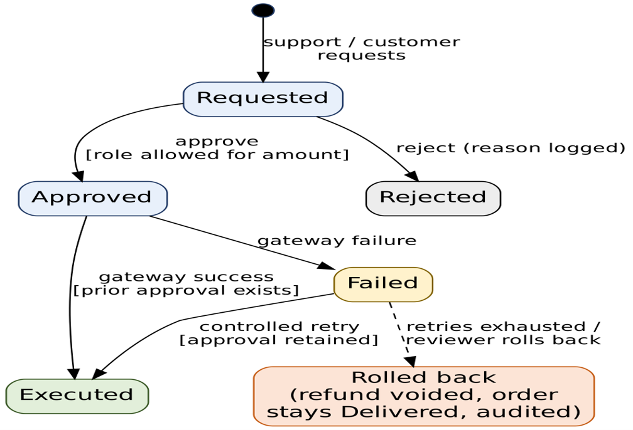
[Regional Storefronts] [Picker Devices] [Scanner Nodes x12]
| HTTPS | HTTPS | local durable queue
+-------------------+-------------+
|
[Load Balancer]
|
+----------+----------+
| API Replica Group |
| Regional API / RBAC |
+----------+----------+
|
private network
|
[Primary PostgreSQL]
/ [Outbox Workers] [Reporting Builder]
| |
[Gateway / Courier] [Summary Database]
The deployment keeps one authoritative database for the initial budget. API replicas and workers scale horizontally within configured limits. Scanner nodes continue capturing events locally during a network interruption, but cannot authorize global refunds or guarantee current global stock. Database failure can still interrupt central checkout and approval.
6.6 Additional redesign validation scenarios
Scenario | Expected behaviour / validation evidence | Status
R1. Load test with 500 users and 1,000 events/minute plus a five-times burst | No duplicate payment/scan effects, negative stock or lost committed intents; measure p95 checkout against the proposed 800 ms target with hardware and dataset recorded. | Proposed test only; capacity has not been measured.
R2. Scanner reconnect replays the same 500-event batch twice | Server applies each node/event identity once; duplicate batch is acknowledged without a second stock movement; queue drains within an agreed recovery period. | Design walkthrough supports unique inbox key and retained event IDs; real scanner/database integration test required.
R3. Regional tax/refund policy changes while scanner is offline | Events retain policy version and observed time; existing order values are not silently recalculated; approval is checked against current authorized policy. | Walkthrough identifies required versioning; regional integration test required.
R4. Offline refund approval request is replayed by stale or unauthorized actor | UI remains Pending Validation; server rejects wrong role, region or stale version and records denial; no Approved or Executed state is created. | Design validation only; identity-provider and endpoint tests required.
R5. One API replica fails during scanner synchronization | Healthy replica accepts retry; deduplication prevents double application. If database is unavailable, scanner retains pending events and reports delayed synchronization. | Proposed deployment test; not executed in a live environment.

6.7 Benefits, costs and trade-offs
The redesign accommodates local regional rules without duplicating the whole application, preserves scanner events during disconnection, prevents duplicate replay effects and protects central refund authority. Stateless API replicas and bounded workers address request and integration capacity. Summary reporting reduces competition between analytics and checkout. Each change maps to FR13–FR17 and NFR07–NFR08.
Costs include scanner storage and maintenance, synchronization protocol/version management, central database capacity, monitoring, queue-age alerts, regional policy governance and stale-event reconciliation. Strong consistency is retained for central order, stock reservation and refund approval. Availability is reduced for operations requiring central authority when the database or approval service is unavailable. Offline scanning captures facts but does not provide globally correct stock or offline refund approval. Reporting is eventually consistent and must show freshness.
Limitations include unknown real event peaks and data volumes, unbenchmarked hardware/database capacity, scanner clock drift and device security, regional legal retention and tax rules, and dependence on one primary database. Multi-region failover or service decomposition requires agreed recovery objectives, data-residency rules and budget evidence.

Task 7 – Individual Technical Reflection
Q7 – Individual Technical Reflection 5 Marks
Explain:
- Which requirement had the greatest influence on your architecture.
- Which stakeholder conflict was most difficult to resolve.
- Which inconsistency was discovered through modeling or validation.
- Which architectural trade-off remains unresolved or significant.
- What additional evidence would be needed before implementing the system.
Evidence Expected
A concise reflection demonstrating understanding of the created design and its limitations. Refer to your own specification, diagrams, decisions and validation findings.

The requirement with the greatest influence on the architecture is FR05, idempotent payment confirmation. It determines the unique gateway/event identity in the data model, the callback transaction, the payment-confirmation sequence and the durable shipment intent. Without it, repeated callback delivery could create duplicate payment or fulfilment effects.
The most difficult stakeholder conflict is fast refunds versus finance control. Customers and support staff benefit from rapid resolution, but a refund is a financial action requiring accountable approval. The design therefore separates request, approval and execution. It also retains approval history when gateway execution fails, allowing a controlled retry without falsely showing the refund as complete.
The most important inconsistency found through modelling and validation was the mismatch between reservation expiry and delayed payment callbacks. The initial lifecycle could mark an order Paid after its stock had been released and resold. The correction re-reserves stock if available; otherwise the order enters Payment Received / Needs Refund and cannot be picked or dispatched. The use-case and security review also corrected the mistaken idea that a browser role selector can grant finance authority.
The significant unresolved trade-off is centralized transactional consistency versus central dependency risk. One relational authority simplifies stock and order invariants and suits a small team, but database failure can prevent authoritative checkout, approval and scanner synchronization. Local scanner queues improve capture continuity, not global availability. Splitting into services could isolate workloads but adds distributed consistency and operating cost.
Before implementation, the retailer should provide measured order and stock query patterns, benchmark results at the target concurrency and event rate, database-level concurrent last-unit tests, payment callback and refund reconciliation contracts, courier idempotency evidence, role/region penetration tests, scanner offline/replay/clock-drift tests, backup restore and worker restart exercises, and approved refund limits, reservation expiry, return windows and data retention rules.

Sources, Tools and Evidence Acknowledgement
Primary source: the supplied CSA10 Software Engineering Assignment 2 document and its faculty evaluation guide. The report follows the task order and scenario constraints, including the changed requirements for twelve regions, 500 simultaneous users, 1,000 events per minute, disconnected scanners, server-validated refund approval and consolidated reporting.
Modelling tool: Umbrello UML Modeller is the recommended tool for recreating the use-case, class, sequence, state-machine, component and deployment diagrams described in this report. The examples are UML modelling guides, not screenshots of an executed Umbrello project. Collaboration arrangement: Confluence and Jira. No live retailer system, gateway, courier service or production environment was accessed. Simulated findings and proposed tests are labelled accordingly.
MARK DISTRIBUTION
Question | Assessed Area | Marks
Q1 | Stakeholder investigation and conflict resolution | 5
Q2 | Prioritized and testable requirements specification | 8
Q3 | UML modeling and requirements traceability | 7
Q4 | Alternative architectures and justified design | 8
Q5 | Critical-behaviour validation and design revision | 7
Q6 | Day-4 Design Challenge – architecture redesign for expansion and partial failure | 10
Q7 | Individual technical reflection | 5
TOTAL |  | 50
Submission Requirements
- Assignment report covering stakeholder analysis, scope, architectural alternatives and tool selection.
- Collaborative requirements specification and issue-tracker records with unique identifiers and acceptance criteria.
- UML diagrams (use case, class, sequence, state machine, component and deployment) and the traceability matrix.
- Architectural decision records, invariants, operation contracts and validation scenarios with expected and observed behaviour.
- Day-4 revisions: impact analysis, revised requirements and diagrams, synchronization rules and validation findings.
- Individual reflection and acknowledgement of sources and tools used.
OBE Assessment Evidence
Successful completion should demonstrate the ability to analyze conflicting requirements, create a testable specification, model the system with UML, evaluate and select an architecture, validate critical behaviour, and revise the design when scale and failure conditions change.
Assessment Verification
Students may be asked to trace a requirement to its UML element, component and validation scenario, explain an order or refund invariant, justify an architectural decision, or revise the design when a requirement changes.
Overall Assessment Expectation
Investigate → Specify → Model → Architect → Validate → Redesign → Defend
The final submission must demonstrate an original, evidence-supported specification and architecture aligned with CO2, BTL 5 – Evaluate and BTL 6 –

